**NOTRE DAME UNIVERSITY BANGLADESH**



Computer Networks

Lab Report-2

**Submitted to:**

Dr. Fernaz Narin Nur

(Adjunct Professor)

**Submitted by:**

Shazidul Alam

Id: 0692220005101009

Batch: CSE-19

**Introduction**

Dynamic routing is a method used in computer networks to automatically adjust the paths of data based on network changes. Unlike static routing, which requires manual configuration, dynamic routing protocols like RIP (Routing Information Protocol) can update routing tables automatically in response to changes in the network topology. This project focuses on implementing dynamic routing using RIP to enable communication between different routers in a simulated network using Cisco Packet Tracer.

**Tools**

**Software**: Cisco Packet Tracer 8.2.1.

**Servers**: 1 PT Server.

**Routers**: 2 PT Routers.

**Switches**: 1 Switch for LAN connectivity.

**End Devices**: 3 PCs to test connectivity.

**Cables**: Serial DCE, Copper Straight-through, Copper Cross-Over.

**Procedure**

**Step 1: Setup the Network Topology**

a. Place the PT-Server.

b. Connect the server with NATRouter using Copper Cross-Over cable.

c. Place two routers (Router 0 and NATRouter).

d. Connect them using a serial cable (Serial DCE).

e. Connect a PC or LAN to each router using Copper Straight-through cable.

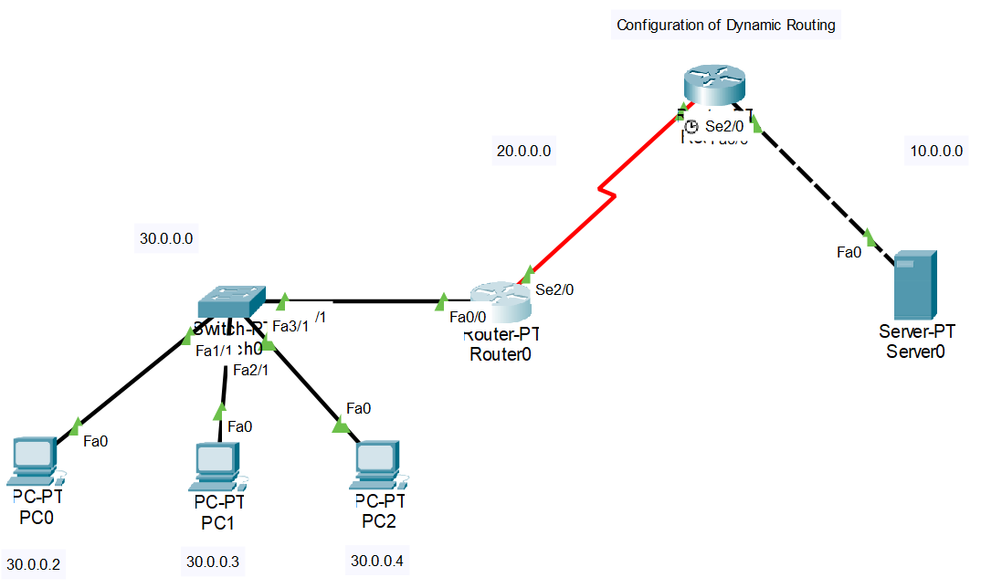

**Step 2: Configure Router 0**

Router>en

Router#conf t

Router(config)#int se2/0

Router(config-if)#ip address 20.0.0.1 255.0.0.0

Router(config-if)#no shutdown

Router(config-if)#exit

Router(config)#int fa0/0

Router(config-if)#ip address 30.0.0.1 255.0.0.0

Router(config-if)#no shutdown

Router(config-if)#exit

Router(config)#router rip

Router(config-router)#version 2

Router(config-router)#network 20.0.0.0

Router(config-router)#network 30.0.0.0

Router(config-router)#exit

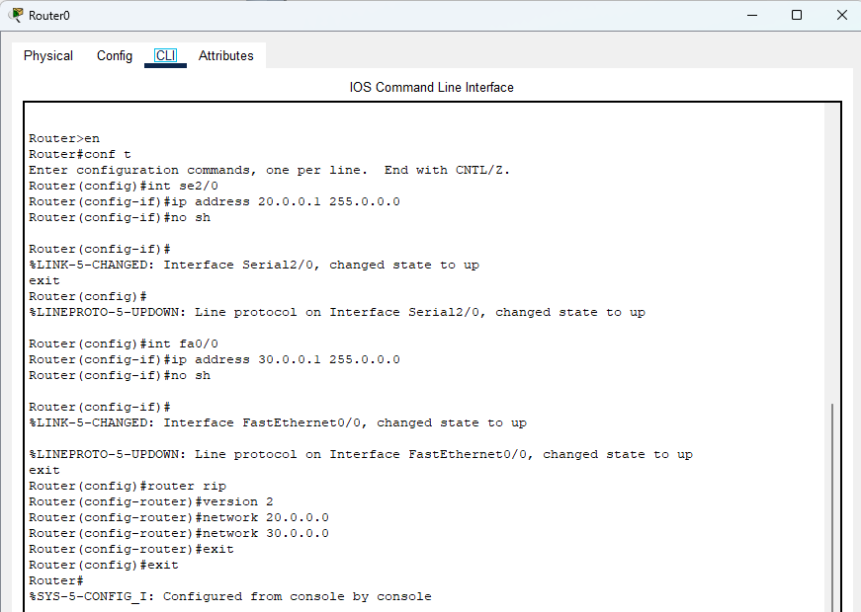

**Step 3: Configure Router 1**

Router>en

Router#conf t

Router(config)#int se2/0

Router(config-if)#ip address 20.0.0.2 255.0.0.0

Router(config-if)#clock rate 64000

Router(config-if)#no shutdown

Router(config-if)#exit

Router(config)#int fa0/0

Router(config-if)#ip address 10.0.0.1 255.0.0.0

Router(config-if)#no shutdown

Router(config-if)#exit

Router(config)#router rip

Router(config-router)#version 2

Router(config-router)#network 10.0.0.0

Router(config-router)#network 20.0.0.0

Router(config-router)#exit

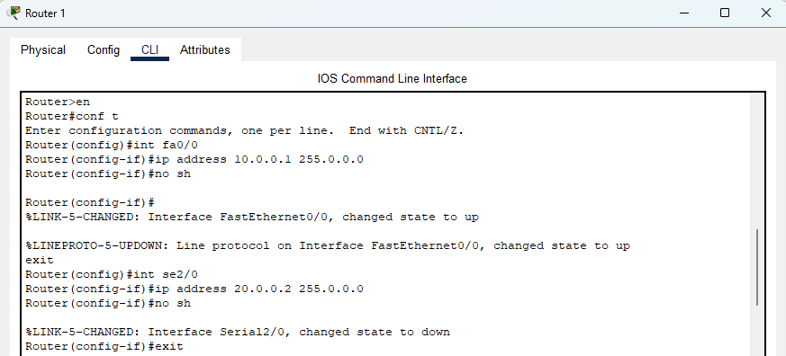

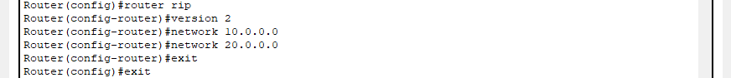

**Step 4: Assign IP to PCs**

PC0 connected to Router 0: IP = 30.0.0.2, Gateway = 30.0.0.1

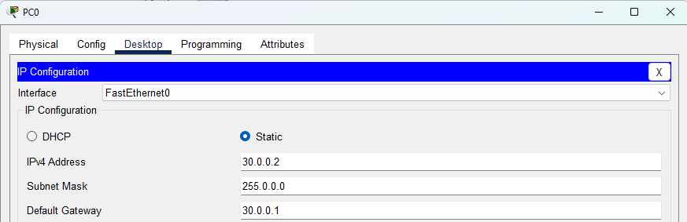

PC1 connected to Router 0: IP = 30.0.0.3, Gateway = 30.0.0.1

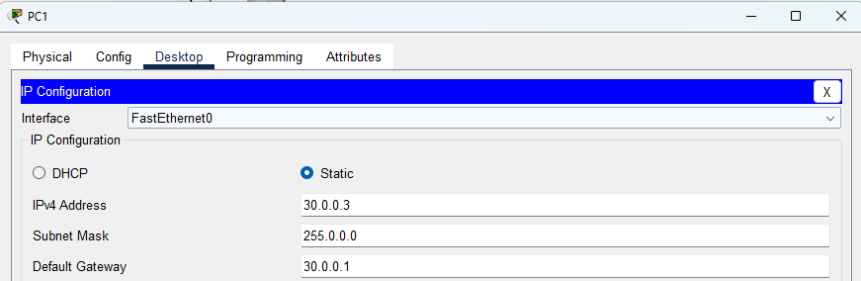

PC2 connected to Router 0: IP = 30.0.0.4, Gateway = 30.0.0.1

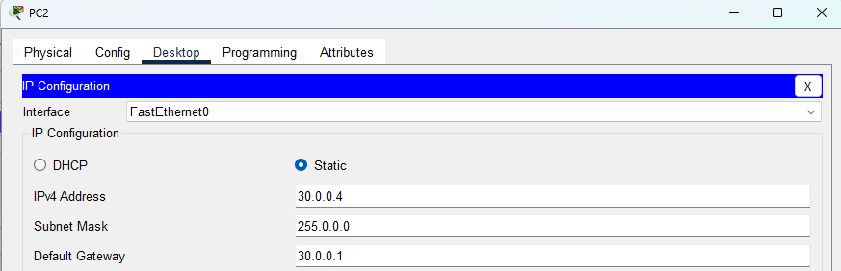

**Step 5: Set-Up server**

Server0 connected to Router1: IP=10.0.0.2, Gateway: 10.0.0.1

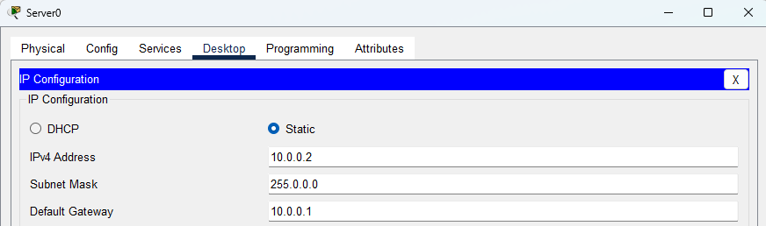

**Step 6: Verify Configuration**

Use the ping command from the command prompt of Server0.

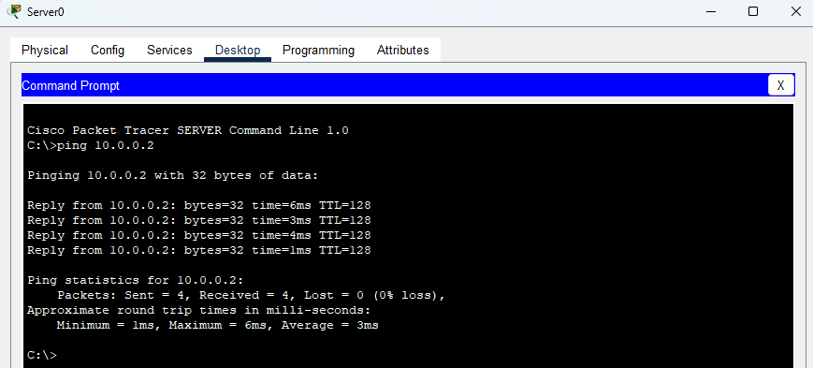

**Conclusion**

Dynamic routing successfully enables automatic route updates and communication between different networks in Cisco Packet Tracer. This approach is scalable and reduces manual configuration efforts.